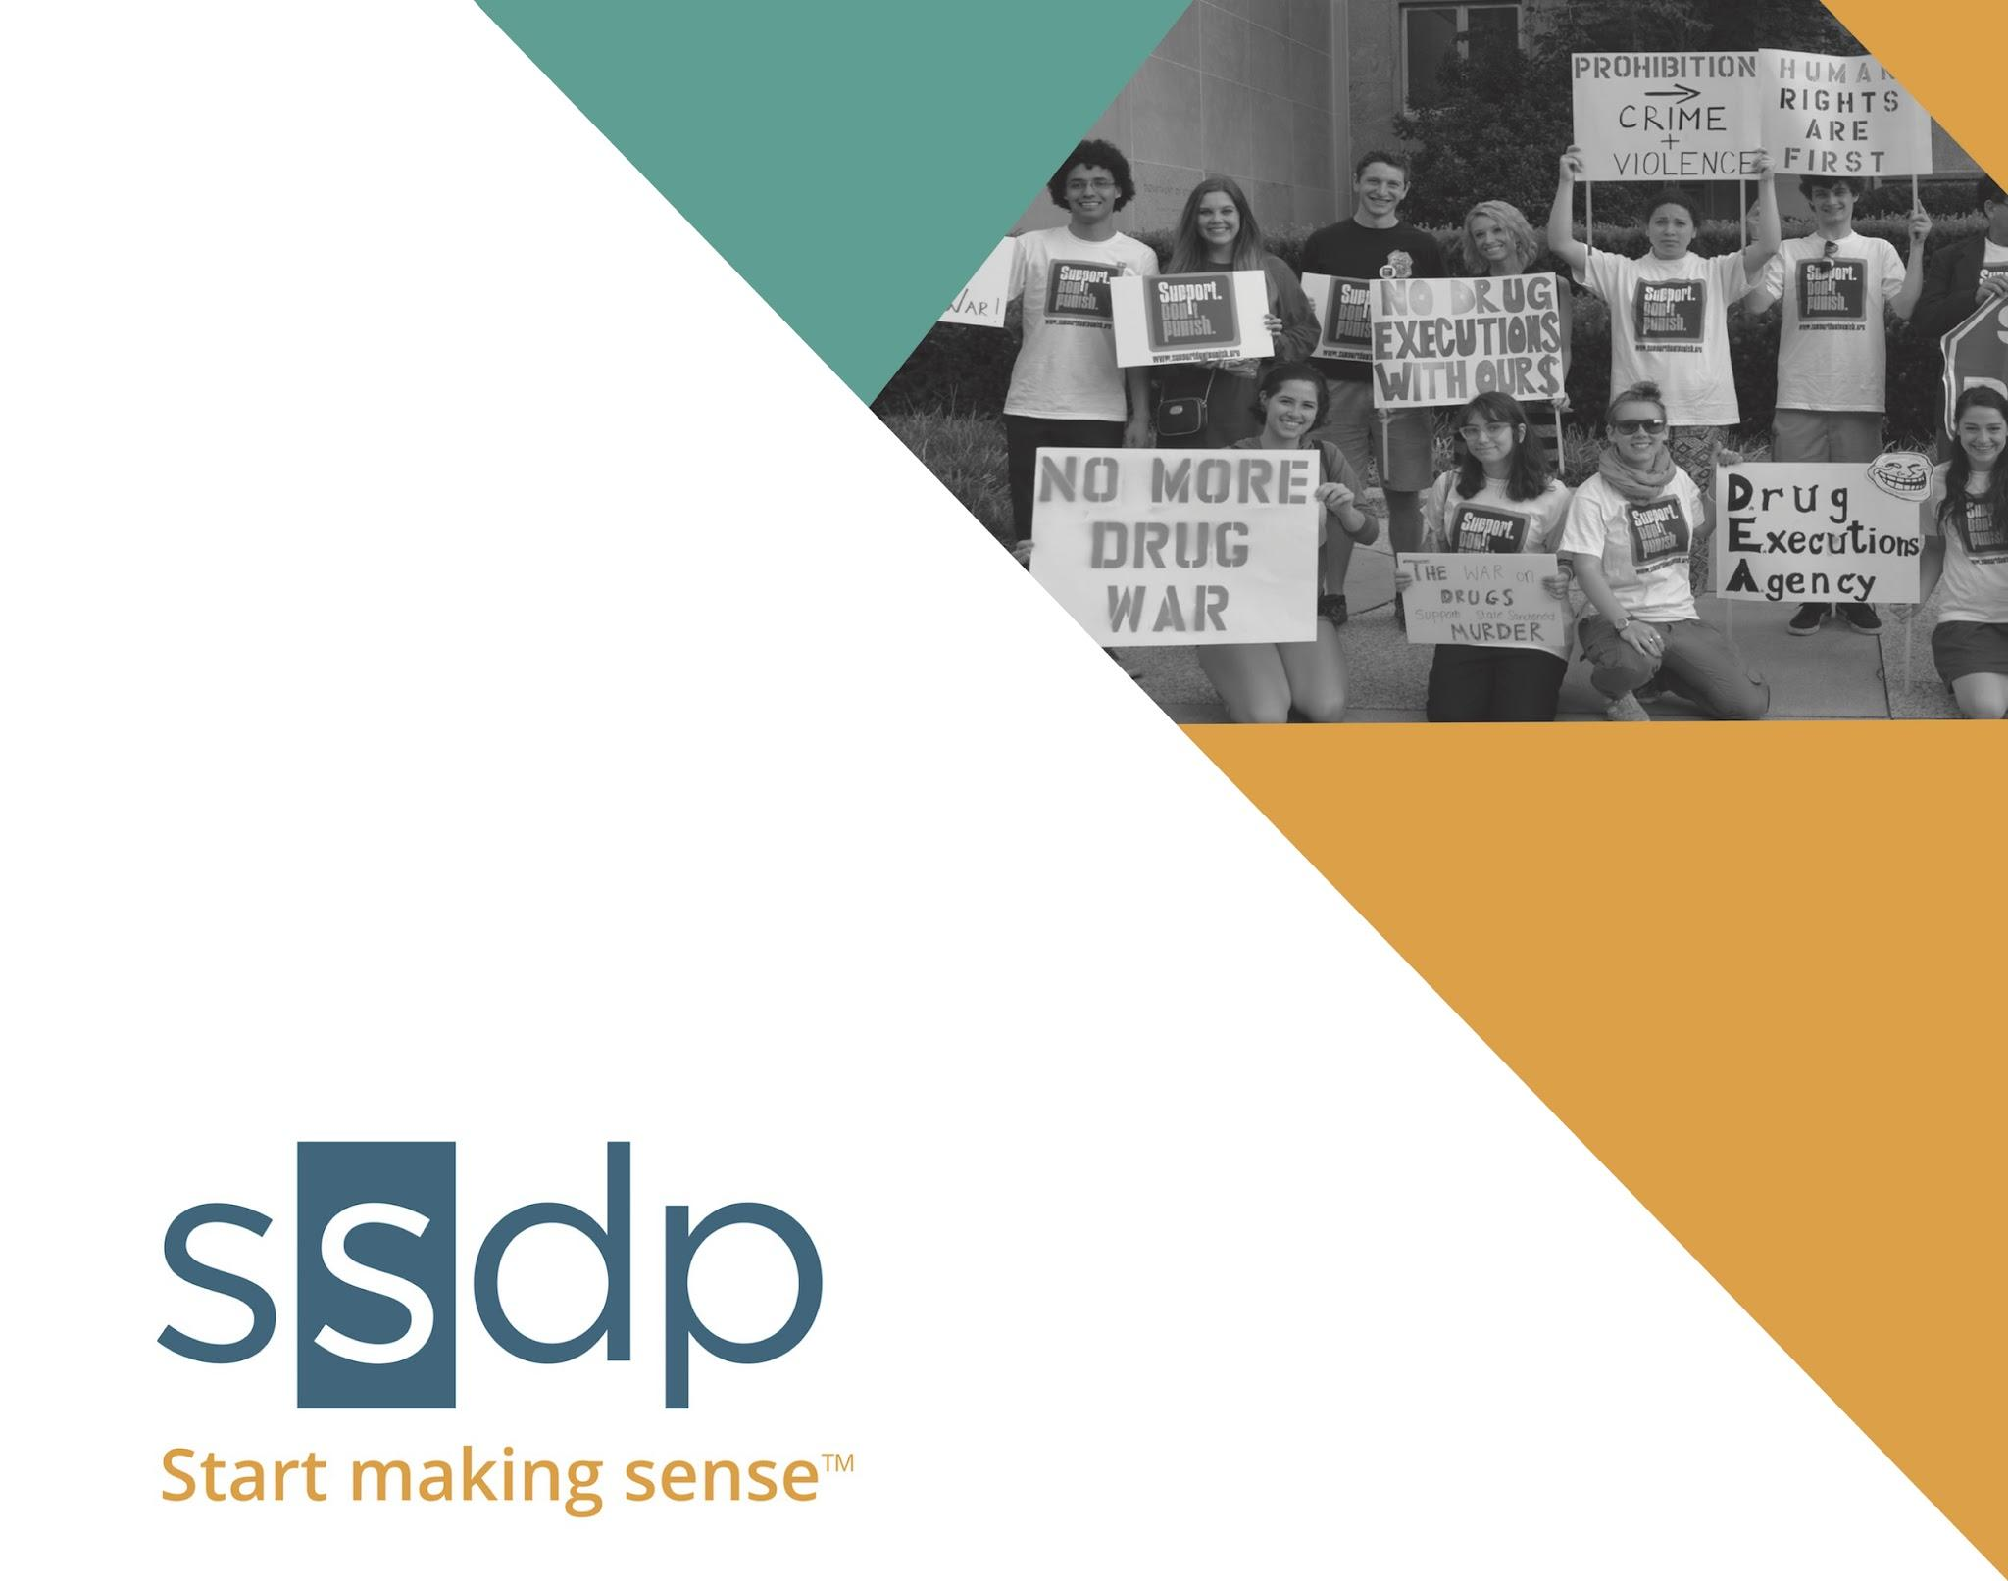

ISSUE TOOLKIT:

PSYCHEDELIC POLICY REFORM



ISSUE **TOOLKIT: PSYCHEDELIC** POLICY REFORM

Advocate for Informed Psychedelic Policies

# **The Issue**

The prohibition of psychedelics has failed. Not only has prohibition failed to eliminate or reduce the rate of use, it also prevents scientific research on these substances and their therapeutic qualities, increases the potential harm for young people who are using these substances, denies the rights of various religious groups, and stigmatizes drug users.

# **SSDP’s Position**

SSDP believes that people who use drugs should have access to honest education, treatment, and should be approached with compassion.

**Model Policy**

This article on Alternet, [Why (and How) We Should Legalize Psychedelics](http://www.alternet.org/drugs/why-how-legalize-psychedelics), provides a broad framework for psychedelic legalization. Some principles of legalization include:

1. Minimum age: 18.
2. Education: At least one coaching session from a trainer about the potential problems and opportunities of use, and what precautions are needed for different psychedelics so as to minimize the chance of bad trips and other serious harms. Training could be based on a standard instruction manual. The trainer, whoever it is, would sign an application for a license for the trainee.
3. Licensing: Following training, licenses may be issued by specified federal, state or local agencies for the purchase of psychedelics. To qualify, applicants would have to pass an appropriate written exam proving they had learned the prerequisite knowledge about safe psychedelic use.
4. Non-sharing: Buyers may not legally share with anyone under age, or outside of consenting licensed family or friends, nor may they resell what they buy to anyone.
5. Violation of these rules will be a violation of law and carry legal penalties.
6. Who may sell psychedelics? Perhaps pharmacies; just as they used to sell contraceptives. Buyers would have to show their licenses.

Why include more stringent restrictions on psychedelics than for marijuana or alcohol? Well, psychedelics are incredibly powerful tools, and must be treated as such. Regulation would mimic the rules we use for operating vehicles, where everyone has potential access, but must be trained in safe operation. Regulations are meant to increase overall safety, not to restrict personal freedom.

# **Background**

## What are psychedelics?

Entheogens, or psychedelics, are part of a wider class of psychoactive drugs commonly known as [hallucinogens](https://en.wikipedia.org/wiki/Hallucinogen), a class that also includes [dissociatives](https://en.wikipedia.org/wiki/Dissociative) and [deliriants](https://en.wikipedia.org/wiki/Deliriant). Entheogens means “god-within” or “spirit-facilitating,” and has been considered a more appropriate term to describe these substances by many scholars, who feel that the term “psychedelics” has a negative connotation ([Tupper 2002:500](http://www.csse-scee.ca/CJE/Articles/FullText/CJE27-4/CJE27-4-tupper.pdf)).” An entheogen is defined as a chemical substance, typically of plant origin, which is ingested to produce a non-ordinary state of consciousness for religious or spiritual purposes. Many of these plants and substances have been used in traditional rituals across various cultures and religions throughout time. Entheogens include [MDMA](http://www.maps.org/research/mdma), [LSD](http://www.maps.org/research/psilo-lsd), [psilocybin](http://www.maps.org/research/other-research), [ayahuasca](http://www.maps.org/research/ayahuasca), [peyote](http://www.maps.org/research/other-research) and more.

This toolkit is intended to serve as a preliminary guide for policy reform for the wide range of substances that are considered entheogens. Given the wide range of effects that each of these substances can have, the regulatory models for each of these substances will look very different. Below, we have used MDMA to serve as an example and a starting point.

## 

## What is MDMA?

[MDMA](https://www.erowid.org/chemicals/mdma/mdma.shtml) is one of the most popular recreational psychoactives, most commonly sold as "ecstasy" (usually tablets) or "molly" (usually crystals). It is known for its empathogenic, euphoric, and stimulant effects, and has also been used in psychotherapy. You can visit [ssdp.org/justsayknow](http://ssdp.org/justsayknow) for more detailed information on the drug’s effects and harm reduction strategies.

## Why legalize MDMA?

### MDMA is medicine.

MDMA is currently being studied as a substance that can be used to [assist with psychotherapy](http://www.maps.org/research/mdma) to help heal psychological and emotional damage caused by sexual assault, war, violent crime, and other traumas, as it is known for increasing feelings of trust and compassion towards others. Preliminary studies conducted by MAPS have shown that MDMA, in conjunction with psychotherapy can help people overcome PTSD, and possibly other disorders as well.

***How does it work?***

In MDMA-assisted psychotherapy, MDMA is only administered a few times, unlike most medications for mental illnesses which are often taken daily for years, and sometimes forever. MDMA is not the same as "ecstasy" or "molly." Substances sold on the street under these names may contain MDMA, but frequently also contain unknown and/or dangerous adulterants. In laboratory studies, pure MDMA has been proven sufficiently safe for human consumption when taken a limited number of times in moderate doses.

***When will it be legalized?***

MAPS is undertaking a roughly $50 million plan to make MDMA into a Food and Drug Administration (FDA)-approved prescription medicine by 2021, and is currently the only organization in the world funding clinical trials of MDMA-assisted psychotherapy. For-profit pharmaceutical companies are not interested in developing MDMA into a medicine because the patent for MDMA has expired. The idea of using [MDMA to assist psychotherapy](http://www.maps.org/news-letters/v23n1/v23n1_p10-14.pdf) of any kind for any specific clinical indication has long been in the public domain.

***See more here:***

* [MDMA-Assisted Psychotherapy for PTSD](http://www.maps.org/images/TreatingPTSD_brochure.pdf)

**Legalizing MDMA would reduce harm.**

Because MDMA is risky and expensive to make, much of what is being sold as MDMA are cheap, unregulated, synthetic substances. People who take “ecstasy” or “molly” are often taking substances that may be adulterated, or may not be MDMA at all. Legalizing MDMA would help take steps towards ensuring a safer experience.

A number of people have died from ingesting what they thought was MDMA, but which actually contained high concentrations of the dangerous drug PMMA. In 2013, the Electric Zoo music festival in NYC was canceled after four party-goers got sick, and two died, from tainted MDMA.

In addition, because of the criminalization of MDMA, many venues refuse to provide basic harm reduction amenities and services, like water, in order to avoid appearing as though they are condoning drug use. University of Virginia sophomore Mary 'Shelley' Goldsmith, 19, died in August 2013 from heatstroke at one of the largest dance clubs in Washington, leading her mother, Diane Goldsmith to launch the [Amend the Rave Act Campaign](https://www.amendtheraveact.org/about-the-campaign/),w[h](https://www.amendtheraveact.org/about-the-campaign/)i[c](https://www.amendtheraveact.org/about-the-campaign/)hc[a](https://www.amendtheraveact.org/about-the-campaign/)l[l](https://www.amendtheraveact.org/about-the-campaign/)so[n](https://www.amendtheraveact.org/about-the-campaign/) [v](https://www.amendtheraveact.org/about-the-campaign/)e[n](https://www.amendtheraveact.org/about-the-campaign/)u[e](https://www.amendtheraveact.org/about-the-campaign/)st[o](https://www.amendtheraveact.org/about-the-campaign/) [provide essential harm reduction amenities.](https://www.amendtheraveact.org/about-the-campaign/) Finally, ending the War on MDMA can help reduce the stigma of being a drug user caused by the War on Drugs. The war on drug stigmatizes the very people it is trying to help by labeling them as criminals. This internalization of guilt and shame may lead youth to use drugs problematically as a method of coping or escaping. In order to reduce harm, we must provide people with honest information and create safe spaces for dialogue.

**Legalizing psychedelics can help us better understand the substances and the human mind.**

Legalizing psychedelics will help us learn more about these substances, and help remove some of the ethical issues that scientists often run into when conducting experiments on illegal substances. The more we learn about psychedelics and how they interact with our bodies, the more we will learn about human mental health, psychology, neuroscience, chemistry and human identity. Check out some of the resources below to learn about psychedelics’ potential:

* ***A Conversation Between Vox Writer Sean Illing and Writer Michael Pollen about Psychedelics and Mental Health:*** [***https://www.vox.com/science-and-health/2018/5/21/17339488/psychedelics-mental-health-michael-pollan-lsd-psilocybin***](https://www.vox.com/science-and-health/2018/5/21/17339488/psychedelics-mental-health-michael-pollan-lsd-psilocybin)
* ***The Beckley Foundation’s Groundbreaking Research With the First fMRI of the Human Brain on LSD:*** [***http://beckleyfoundation.org/the-brain-on-lsd-revealed-first-scans-show-how-the-drug-affects-the-brain/***](http://beckleyfoundation.org/the-brain-on-lsd-revealed-first-scans-show-how-the-drug-affects-the-brain/)
* ***Read About an Upcoming Clinical Trial Comparing Psilocybin to a Common SSRI to Treat Depression:*** [***https://www.bbc.co.uk/news/health-44575139***](https://www.bbc.co.uk/news/health-44575139)
* ***A new study from the University of California, Davis found that LSD and DMT promote neural plasticity and development:***

[***http://beckleyfoundation.org/2018/06/13/psychedelics-promote-neural-plasticity/***](http://beckleyfoundation.org/2018/06/13/psychedelics-promote-neural-plasticity/)

# **Strategies for Change**

This policy can be implemented at the campus, local, or state level and should include a public opinion and education campaign.

For specific strategies and tips on enacting the following, check out our [Campus Change Toolkit.](https://docs.google.com/document/d/1jcNLBk1oTg-soRkrUYR50WkIPBHGXJ4kJdBtWaVR8Yw/edit)

## Public opinion and education

**Devote one chapter meeting to educate chapter members and the community on psychedelics and what they can do to change policy.** Here are some steps to a successful meeting:

* Logistics: Set a meeting date, time, and location and ADVERTISE!
* Conduct Research. What are psychedelics? What are their effects, both positive and negative? What are the current policies surrounding psychedelics? What are the effects of these policies? Why is it important to reform these drug policies? What are the effects of current policies surrounding psychedelics, both positive and negative? Compile this into a presentation. Visit <http://www.ssdp.org/justsayknow> for template presentations on LSD, MDMA, and Psilocybin.
* Brainstorm. Allow enough time for chapter members to talk about the issue and decide what direction your chapter wants to go. Use this guide as a starting point. Remember, successful drug policy advocacy and reform should be designed to meet people where they’re at, and be tailored based on your campus and community interests. Consider forming a committee to spearhead efforts.

**Write a Letter To the Editor (LTE) about the importance of legalizing psychedelics.** Since both the public and policymakers get information about public policy issues from the news, you should work with the press to get positive coverage of your chapter’s efforts to raise awareness about psychedelics. One of the easiest ways to get press is to write a Letter To the Editor (LTE). [The Media Awareness Project](http://www.mapinc.org) is a clearinghouse for LTEs about the Drug War, and has sections specifically for [Ecstasy](http://www.mapinc.org/mdma.htm), [Hallucinogens](http://www.mapinc.org/hallucinogens.htm) and [Club Drugs](http://www.mapinc.org/find?158). It is user-friendly, and offers tips on how to write a LTE.

* Write a letter to the editor focusing on how psychedelic research offers crucial progress in fields like mental health, neuroscience, ect.
* Use your Resources. Check out [LTE Tips](http://ssdp.org/resources/lte-tips/) on our [Resources page](http://www.ssdp.org/resources) for a guide. Contact your Movement Fellow if you have any questions.
* Spread the Word. When your LTE is published, be sure to post it to various Facebook groups, and let your Movement Fellow know! Your OC will help you publicize it on Facebook and on the SSDP website.
* Make media a cornerstone of your chapter’s actions. Think about it every time your chapter does anything. The [Media Survival Guide](http://ssdp.org/resources/media-guide.pdf) including advice on press releases and doing interviews. Contact our [advocacy fellow](mailto:hannah@ssdp.org) for press lists and talking points.

**Invite a Psychedelic Expert to your campus.** Build support and awareness of the issue by inviting a speaker to your campus. Check out SSDP’s resource on [successfully hosting a speaker!](https://docs.google.com/document/d/1zb0jScA6F6_wdXeeRVRkuJ6B8pAitV5vfYqZOxEvSJQ/edit)

## Campus Change

**Lobby Student Government and Faculty Government to Support Psychedelic Research.** While the potential for national psychedelic policy reform may be distant, there are still incremental actions you can take on campus to raise awareness of the issue and get closer to garnering support for full psychedelic legalization. Resolutions can be a powerful way to exemplify student support for these initiatives to community members, media, and legislators, and can be helpful for when SSDP members meet with stakeholders. To lobby your Student Government and Faculty Government:

* Find a Champion. Do your research, and find a student government representative or faculty member that will help you pass the resolution. Contact the person and e-mail them a legislative paper and request a meeting. Here is a sample legislative paper on [Treatment and Prevention Accessibility](http://ssdp.org/assets/files/campaigns/ccc/treatmentprevention/treatment-prevention-sg.doc).
* Know the Process. Ask your champion what you need to do to get the resolution passed. It will probably involve presenting your argument at a meeting, and educating other members, and gathering signatures for a petition.
* Garner Media. This is a great time to write an opinion-editorial about why it is important for student government to pass a resolution in support of research on psychedelic substances. Positive press will help. Notify the press when you pass the resolution.
* Use your Resources! Contact our [advocacy fellow](mailto:hannah@ssdp.org) to help you with logistics, talking points and legislative questions.
* Identify relevant groups on campus; mental health advocacy groups, psychology researchers, etc.

**Lobby / work with University Administration to include psychedelics in school drug/alcohol education programs.** Sometimes the best way to promote change is to start from the inside out.

* Partner with your school’s health services program to include programs on MDMA, LSD, MDMA, Psilocybin and more in the curriculum, or develop your own programs and invite health services and the campus community to attend. Visit <http://www.ssdp.org/justsayknow> for sample presentations, and contact SSDP’s Drug Education Manager, Vilmarie Narloch at [vilmarie@ssdp.org](mailto:vilmarie@ssdp.org) for more guidance.
* Create info guides with basic psychedelic drug info; reference [DanceSafe’s LSD](https://dancesafe.org/lsd/) info guide as a sample info guide.

## State/Municipal Reform

* **Write to a congressman about psychedelic research, legalization, and/or education.** Click [here](http://www.thecannabist.co/2016/08/03/oregon-rep-earl-blumenauer-medical-marijuana-veterans-affairs/60173/) for an example written by Congressman Earl Blumenauer about medical marijuana for veterans.

## Federal Reform

**More Resources**

* [MAPS](http://www.maps.org/resources/freebooks)
* [Aware Project](http://awareproject.org/)
* [Transform UK](http://www.tdpf.org.uk/resources/benefits-legal-regulation)
* [What's In My Baggie? (Video)](https://www.youtube.com/watch?v=dYzmZ1IU4zY)
* [Food of the Gods - Terrence McKenna (Book)](http://herbarium.0-700.pl/biblioteka/Food%20of%20the%20Goods.pdf)
* [The Psychedelic Policy Quagmire - Thomas B. Roberts (Book)](https://books.google.com/books?id=FK1mCgAAQBAJ&pg=PA175&lpg=PA175&dq=The+Psychedelic+Policy+Quagmire+-+Thomas+B.+Roberts+pdf&source=bl&ots=msIbExSpBa&sig=0C7jvusKgJQXbgsC4i5OLeWCLkI&hl=en&sa=X&ved=0ahUKEwjEsNjO1u3JAhXELB4KHUc-DkkQ6AEIHDAA)
* [Study of psychedelics use by clergy participants aims to induce mystical experiences](http://www.christiancentury.org/article/2015-10/study-psychedelics-use-clergy-participants-aims-induce-mystical-experiences)
* [Calling all mystics: Clergy psychedelic study aims to awaken spiritual experiences](http://www.religionnews.com/2015/10/22/calling-mystics-psychedelic-study-aims-induce-spiritual-experiences-clergy/)
* [Rick Doblin - Legalizing Psychedelic Therapy](https://vimeo.com/143494737)
* [Why and How We should Legalize Psychedelics](http://www.alternet.org/drugs/why-how-legalize-psychedelics)
* [The most convincing argument for legalizing LSD, shrooms, and other psychedelics](http://www.vox.com/2015/7/24/9027363/acid-lsd-psychedelic-drugs)

MDMA

* [Emanuel Sferios, DanceSafe Speaker](mailto:sferios@gmail.com)
* [Transform: Policy and Resources](http://www.tdpf.org.uk/resources)
* [EmmaSofia: Increasing access to MDMA and Psychedelics](http://www.emmasofia.org/)

LSD

* [MAPS: LSD-Assisted Psychotherapy](http://www.maps.org/research/psilo-lsd)
* [The Electric Kool-Aid Acid Test - Tom Wolfe](http://www.jfki.fu-berlin.de/academics/SummerSchool/Dateien2011/Presentation_Handouts/Handout_-_Duncan_-_September_14_-_De_Crescenzo.pdf)

Psilocybin

* [920 Coalition](http://www.920coalition.org/)

Ibogaine

* [MAPS - Ibogaine Therapy for Drug Addiction](http://www.maps.org/research/ibogaine-therapy)

Ayahuasca

* [MAPS - Ayahuasca Assisted Treatment](http://www.maps.org/research/ayahuasca)

LSD

Psilocybin

MDMA

Ibogaine

Ayahuasca

2C-B

Miscellaneous



 